

**Placement Empowerment Program**

***Cloud Computing and DevOps Centre***

***Back Up and Restore a Cloud Instance*** *: Take a snapshot of your cloud VM. Terminate the VM and restore it from the snapshot.*

**Name: VIJAYA NANDANA M Department: CSE**

**Introduction**

In today's cloud-driven world, ensuring data availability and reliability is paramount. This Proof of Concept (POC) focuses on the Backup and Restore process for a cloud instance, showcasing how critical data can be safeguarded and restored efficiently in AWS. By taking a snapshot, terminating the instance, and restoring it from the snapshot, this POC demonstrates the ease and reliability of AWS Elastic Block Store (EBS).

**Objectives**

* Demonstrate the process of creating and managing backups in AWS.
* Explore the capabilities of EBS snapshots for disaster recovery.
* Understand how to restore a terminated instance and verify data integrity.
* Highlight cost-saving techniques using AWS Free Tier while ensuring operational readiness.

**Step by Step Overview**

**1. Create an EC2 instance**

- log into your aws account.

- create an EC2 instance called “Back Up instance”.

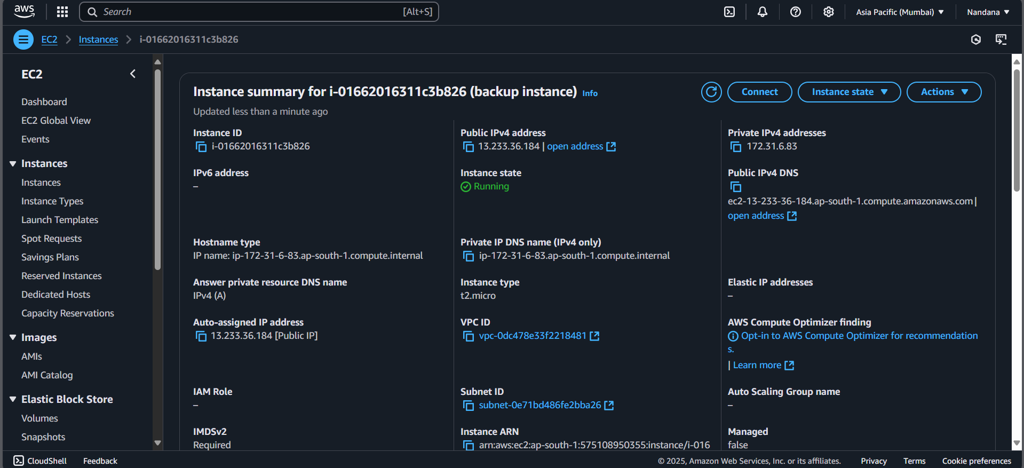

**2. Create EBS volume**

* Go to the EC2 Dashboard in the AWS Management Console by selecting EC2 from the Services menu.
* In the left-hand menu, under Elastic Block Store, click on Volumes, then click the Create Volume button. Select General Purpose SSD (gp3) for the volume type, set the size (e.g., 8 GiB, within Free Tier limits), and choose the availability zone that matches your EC2 instance (e.g., us-east-1b).
* Leave the other options as default, then click Create Volume.
* Be sure to note the Volume ID for future reference.

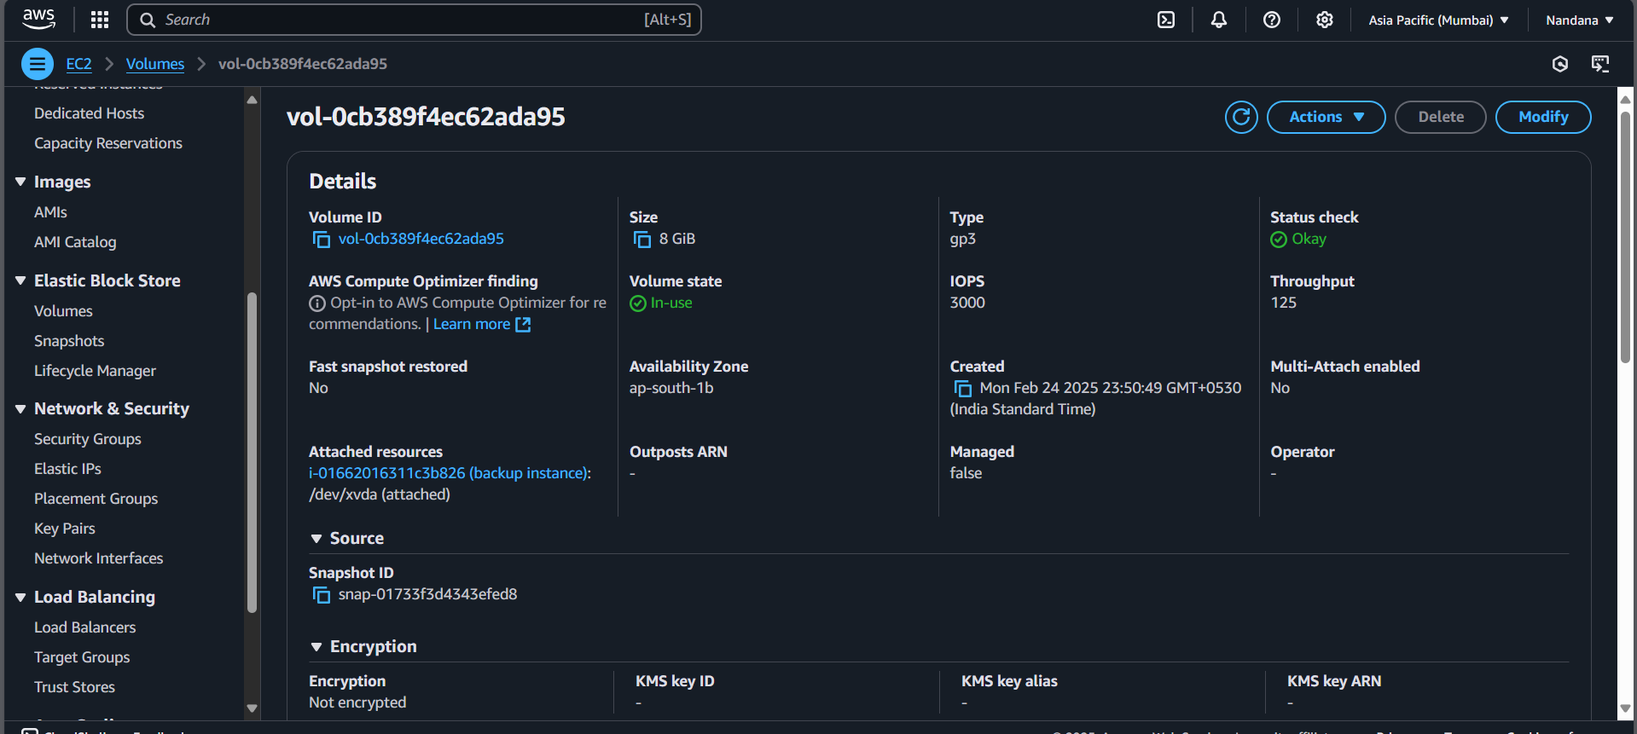

### **3. Create Snapshot**

* To create a snapshot of your EBS volume, navigate to the EC2 Dashboard in the AWS Management Console and click on Volumes under the Elastic Block Store section.
* Locate the volume attached to your instance (it should match the instance name or ID), select it, then click Actions > Create Snapshot. Click Create Snapshot.
* To monitor its status, go to Snapshots under Elastic Block Store in the left menu and wait for the status to change to Completed.

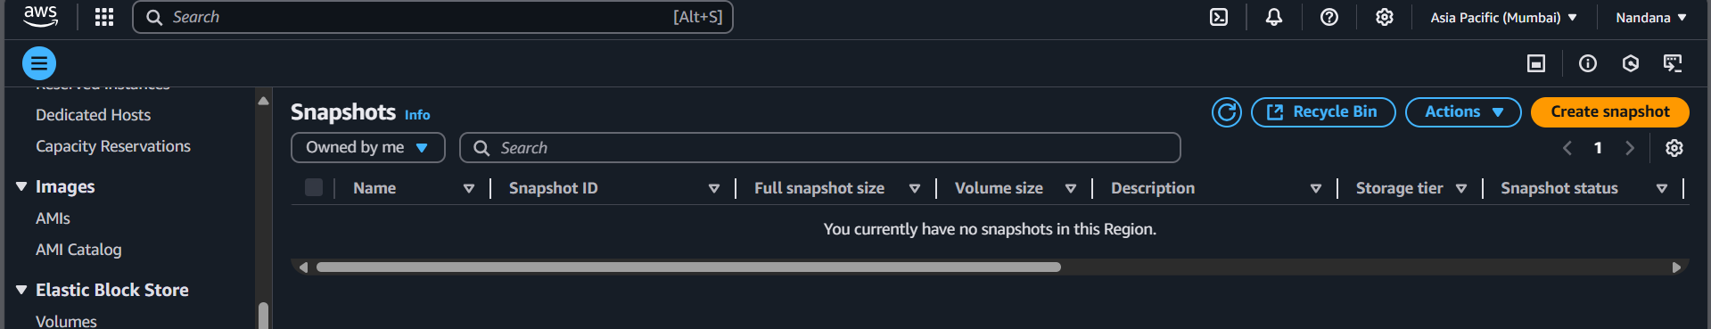

**4. Terminate the ec2 instance**

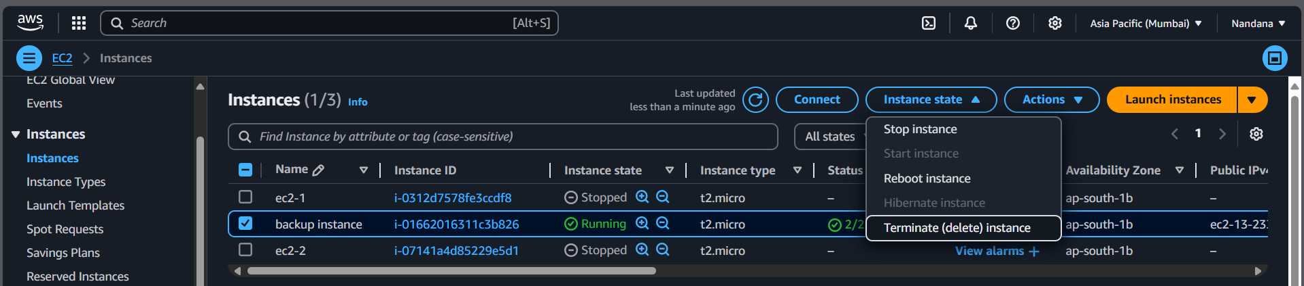

**5. Create a new volume from the snapshot**

To go to the EC2 Dashboard and click on Snapshots under the Elastic Block Store section in the left menu. Select the snapshot you created earlier, then click Actions at the top and choose Create Volume. In the configuration settings, leave the Size as is (it will match the snapshot size) and select the same Availability Zone where you want to restore your instance (e.g., us-east-1a). Finally, click Create Volume to complete the process.

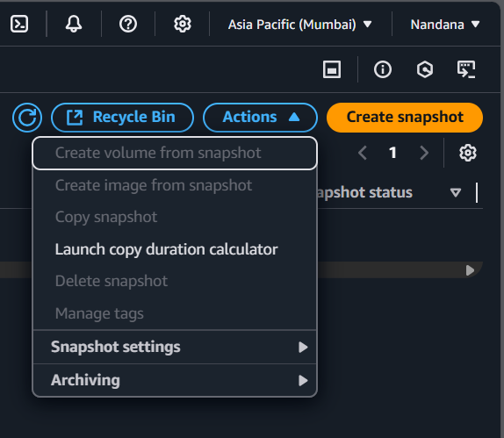

**5. Launch new instance.**

To launch a new instance, go to the EC2 Dashboard and click Launch Instances. Set the name of the new instance (e.g., Restored-POC VM) and choose the same AMI (e.g., Amazon Linux 2023 Free Tier eligible) as the original instance. Select t2.micro for the instance type (Free Tier eligible). Configure the instance as needed, but skip the storage section for now.

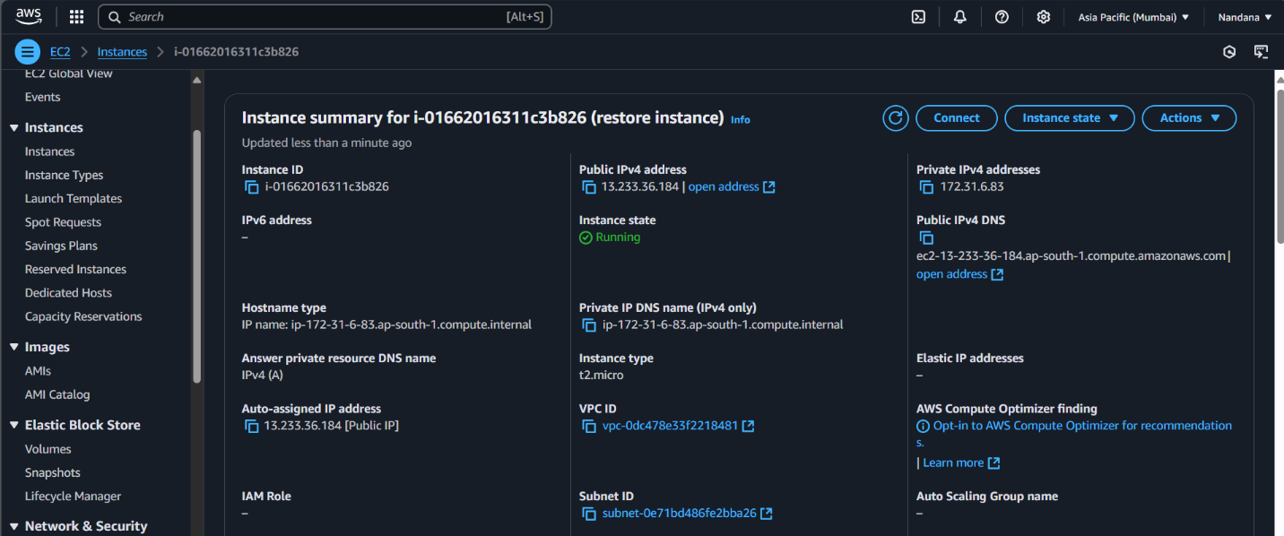

**6. Attach the volume to the instance**

First, stop the instance temporarily after it is launched by selecting the new instance, then click Actions > Instance State > Stop Instance. Next, go to Volumes in the left menu and select the new volume created from the snapshot. Click Actions > Attach Volume, and in the pop-up window, choose the new instance to attach the volume.

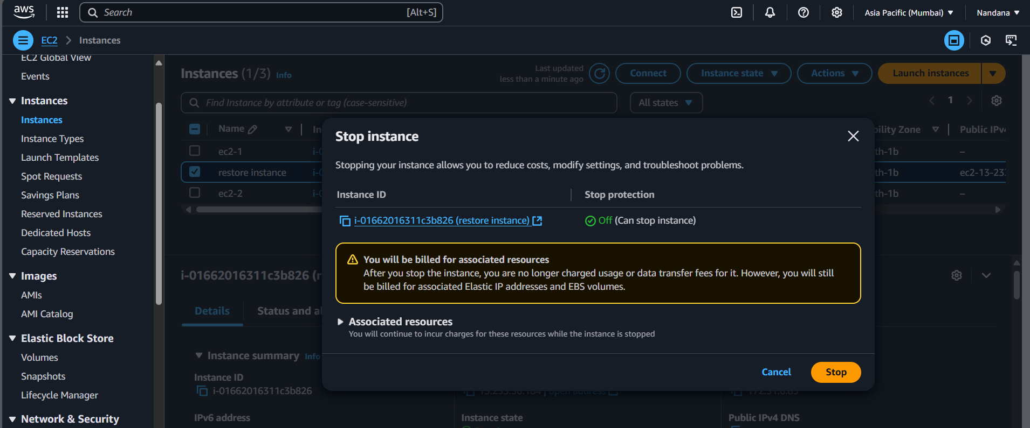

**7. Verify**

Connect to the instance using SSH or other methods. 2. Check if the files, data, and configurations match the original setup.

**Outcome:**

* Created a Snapshot of your instance.
* Terminated the Instance to avoid extra charges.
* Restored the Instance using the snapshot by creating a volume and attaching it to a new VM.